**Calculator**

**Design:** Calculator was designed with NodeJS on backend and ReactJS on frontend. User inputs the operands to perform calculations one by one. Select operand 1 🡪 operator 🡪 operand2 🡪 press equals. Once Equals is hit, the server is sent an API call to perform the calculations and the result is then sent back to the display.

**APIs:** There is a single API to handle all the calls and calculation method is passed as an input.

**Sample Output** :

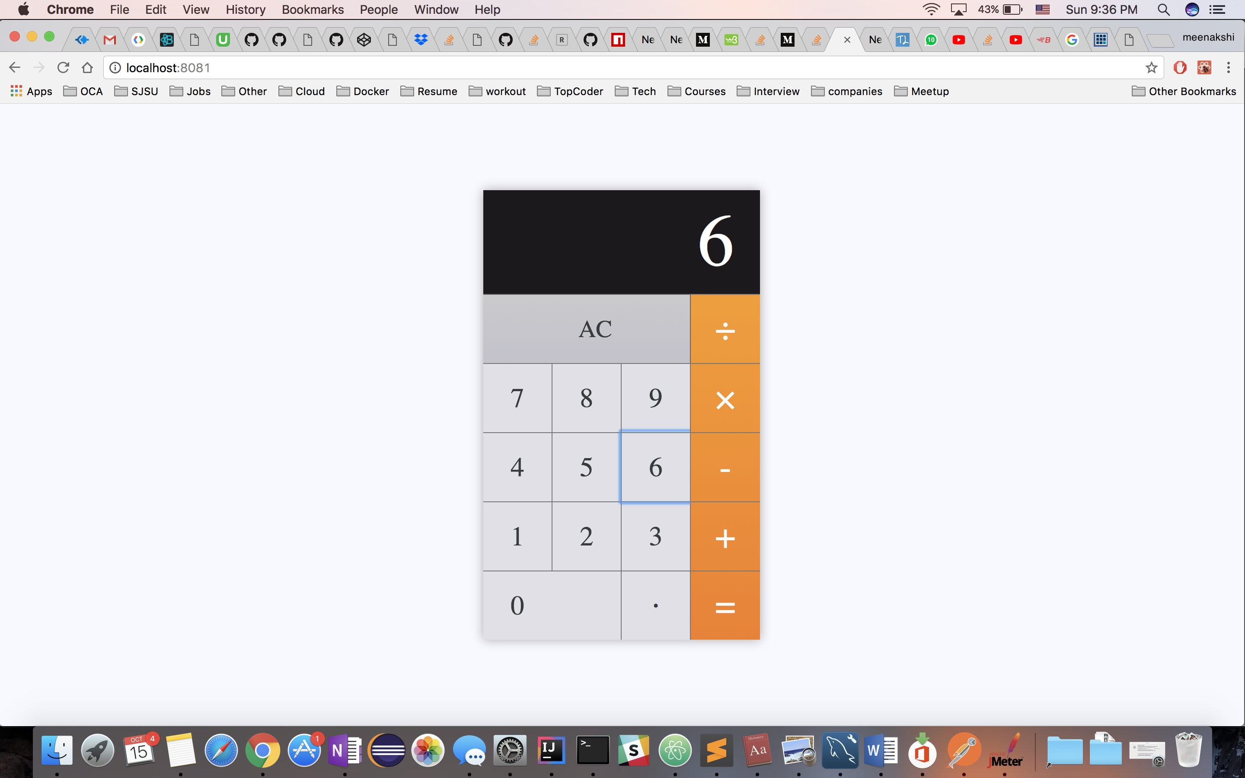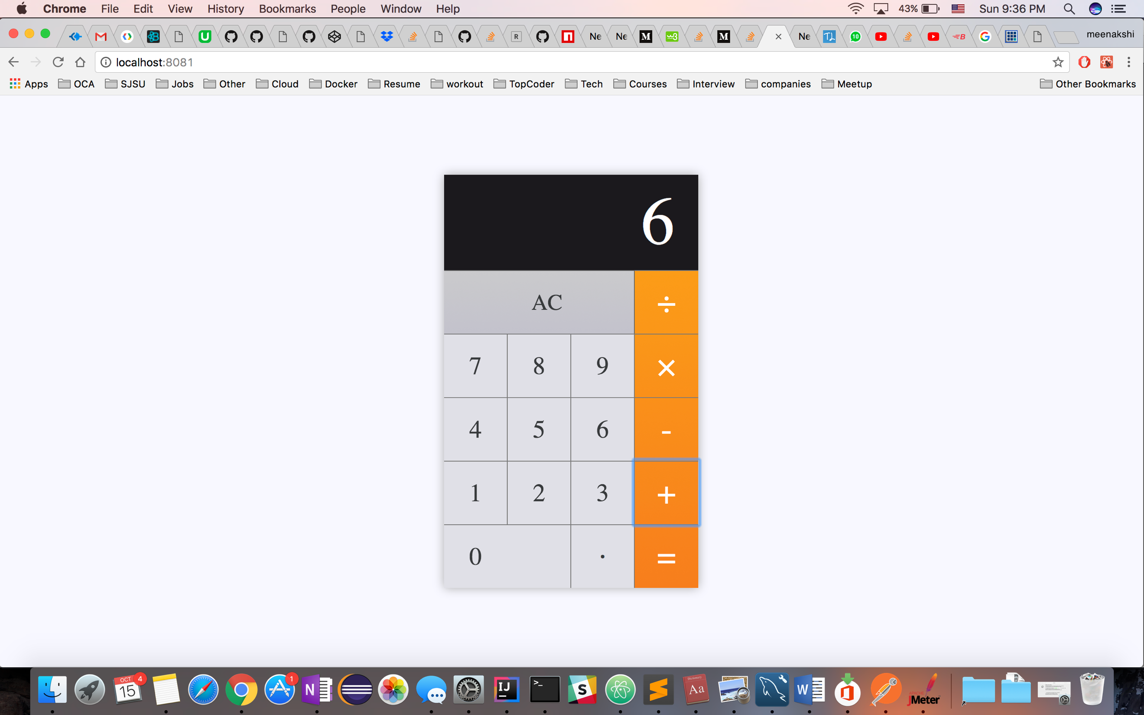

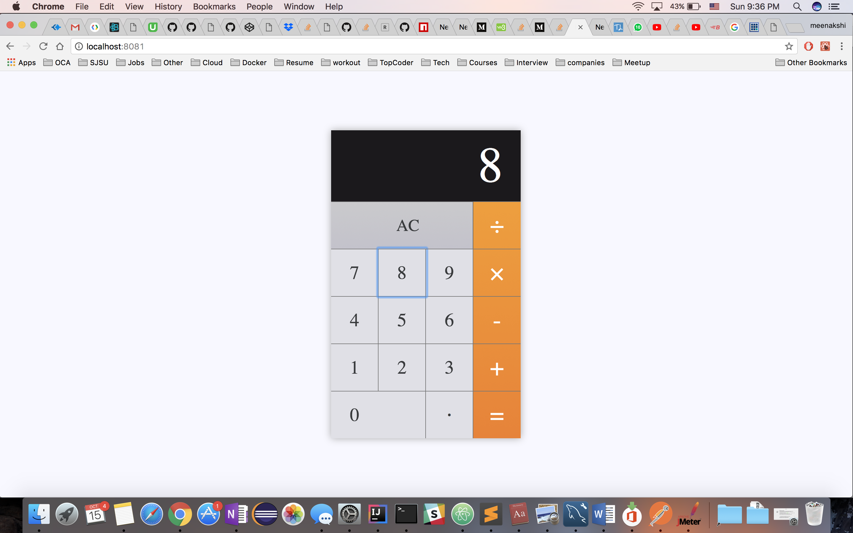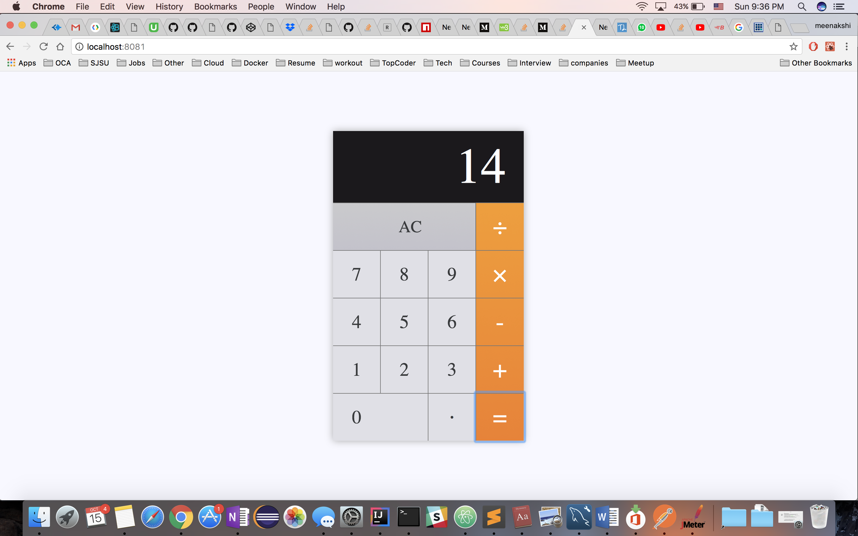

**JMeter Performance test:** Calculator API performance was tested using JMeter. It was tested using different user group and loop counts.

**Scenario 1:** First test was conducted with 1 user and 1000 calls for that user. Below was the average time marked for all the 1000 API calls, **Average time –** **51 ms for 1000 API calls.** There was a sharp ramp in the average time taken.

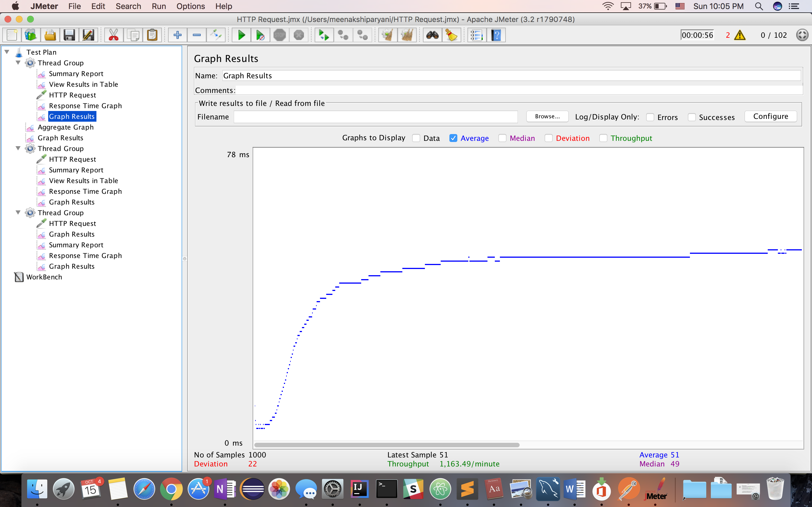

**Scenario 2:** Second test was conducted with 1 user and 5000 API calls for that user. Below was the average time marked for all the 5000 API calls, **Average time –** **11 ms for 5000 API calls.** The average time significantly dropped as the number of calls increased for the same user.

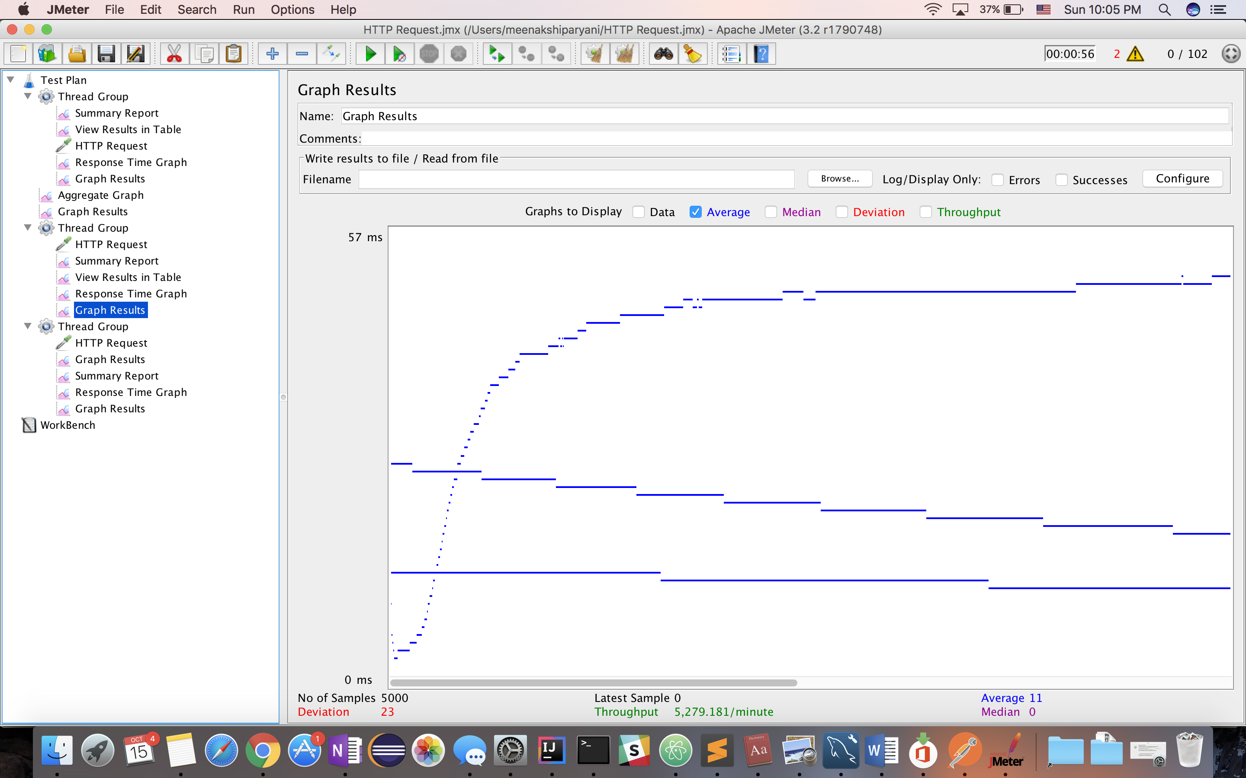

**Scenario 3:** The third test was conducted with 100 users and 1000 requests for each user. Below was the average time marked for all the 100,000 API calls, **Average time –** **53 ms for 100,000 API calls.**

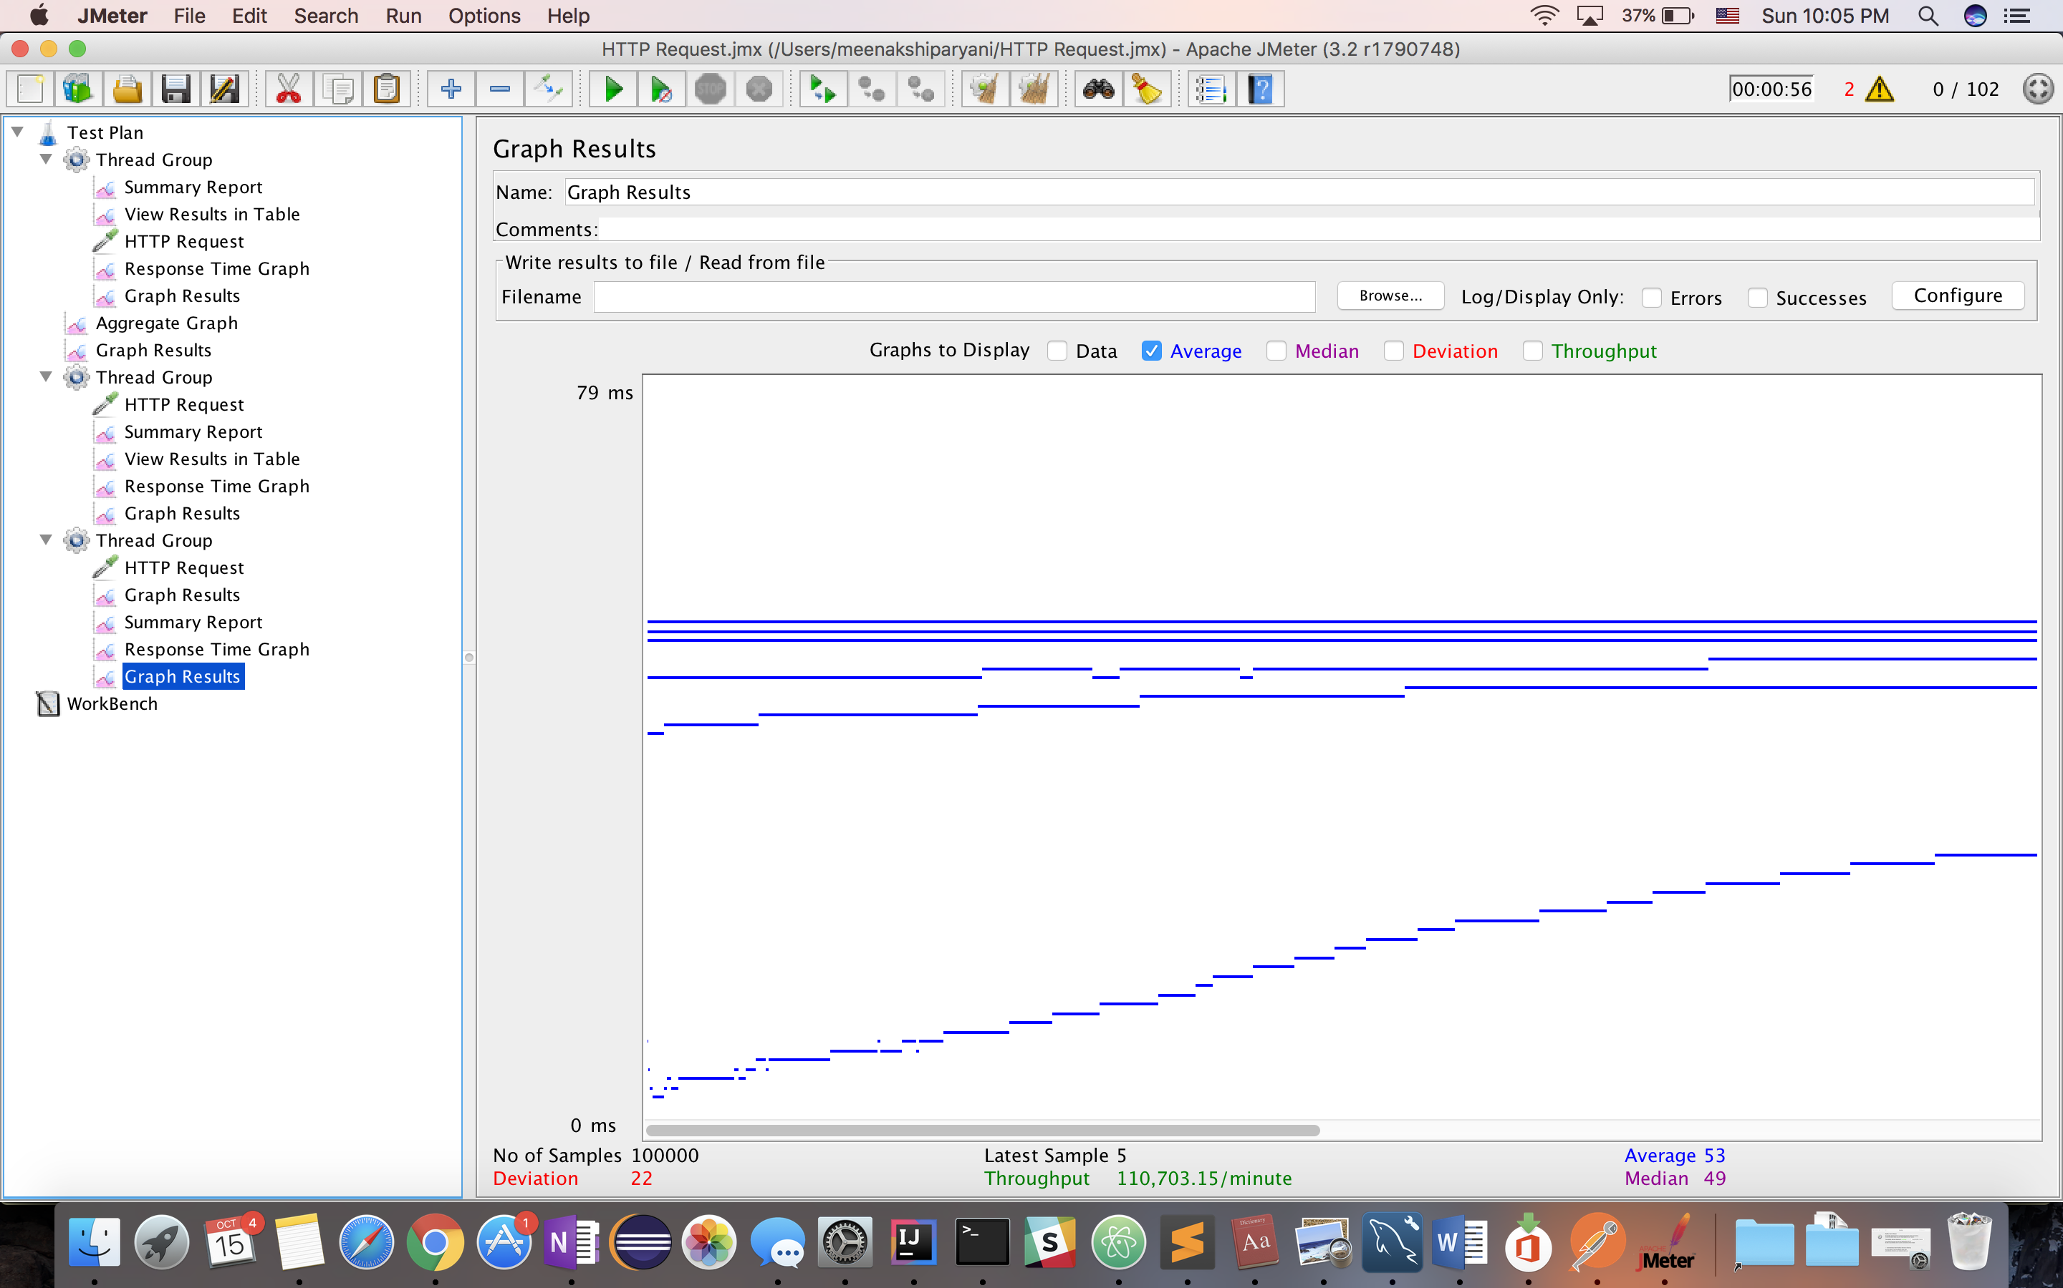

**Aggregate Results**: The average response time considering all the above 3 scenarios was marked as below. As there was a varied API call samples for this scenario, the average response time is closer to the one with maximum number of API calls i.e in Scenario 3. **After an initial ramp, as the number of calls increased, the average response time also increased.**

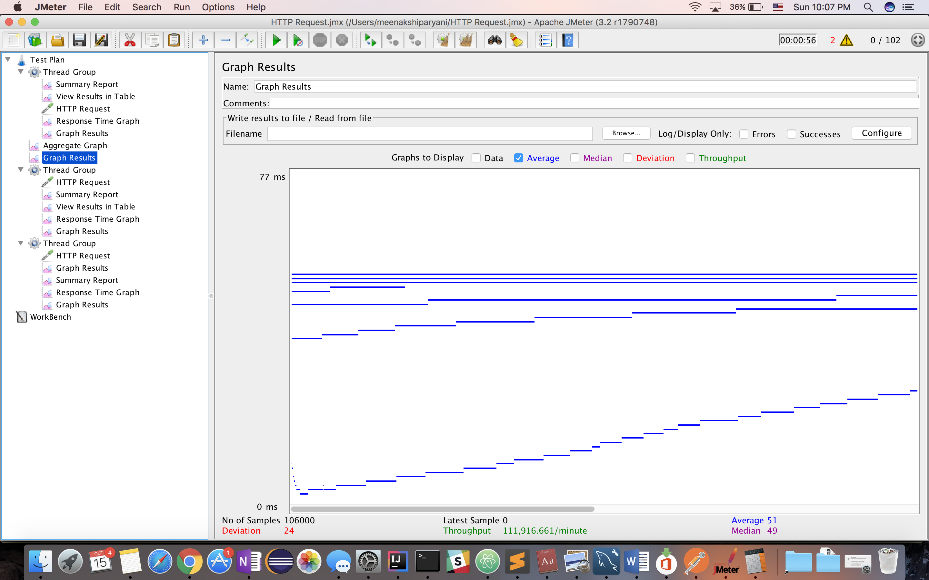

**Dropbox testing JMeter:** Dropbox was tested with and without mysql connection pooling for users in range of 100, 200, 300, 400 and 500 concurrently.

**Without Connection pooling**: Without connectionpooling, the average time noted for all the user scenarios was as below. The average time was noted to be about **8846ms (8.8 sec)**

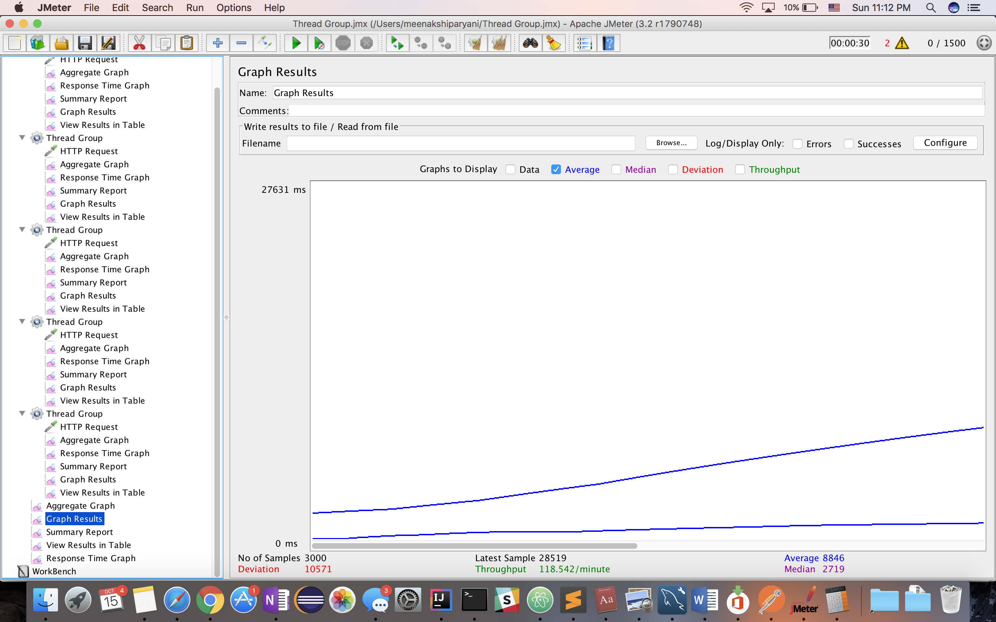

**With Connection pooling:**

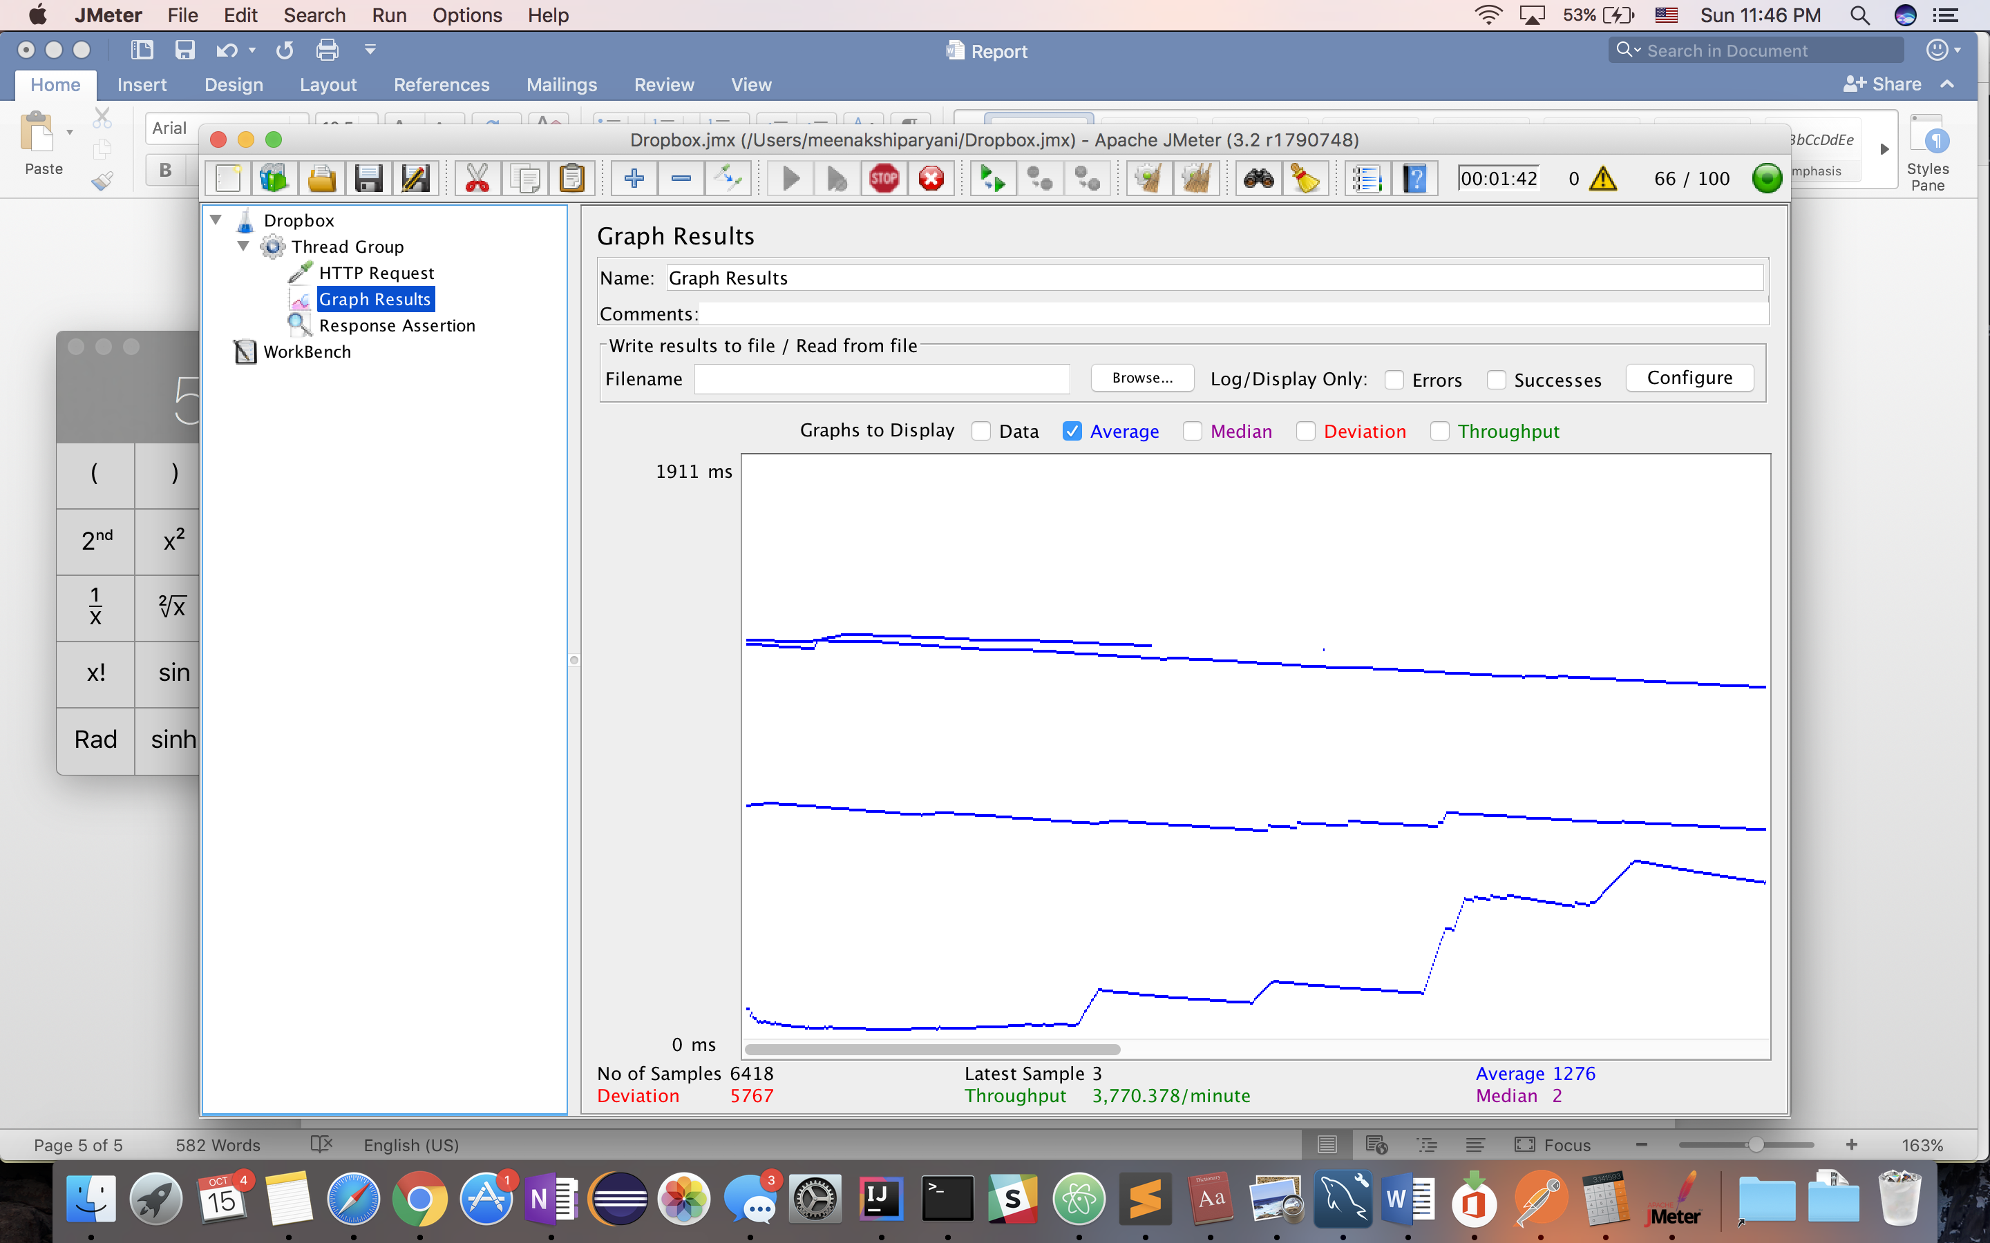

**Encryption algorithm**: The encryption algorithm used was **bcrypt**. Besides incorporating a salt to protect against rainbow table attacks, bcrypt is an adaptive function: over time, the iteration count can be increased to make it slower, so it remains resistant to brute-force search attacks even with increasing computation power. The other alternates were as follows :-

* jCryption
* Standford Javascript crypto library
* CryptoJS
* ForgeJS

Bcrypt was used because of seemless integration with react and its support for the salt and hash functions which provide great deal of security which is generated synchronously.

**SQL Caching**: The query cache stores the text of a SELECT statement together with the corresponding result that was sent to the client. If an identical statement is received later, the server retrieves the results from the query cache rather than parsing and executing the statement again. The query cache is shared among sessions, so a result set generated by one client can be sent in response to the same query issued by another client.

The Query Caching is one of the caching mechanism used to improve performance. In the project, I used query cache to improve the query performance and hence the overall system performance.

**Session Strategy**: session strategy was configured to be horizontally scalable. With the use of mysql caching and connection pooling, the application was able to handle many users at a time as demonstrated by the Jmeter results.

**Application Screenshots**:

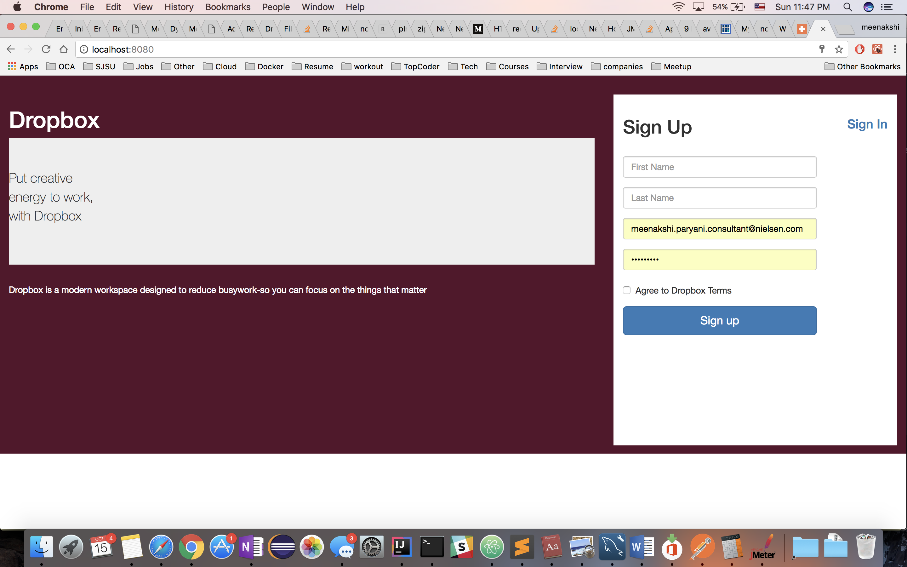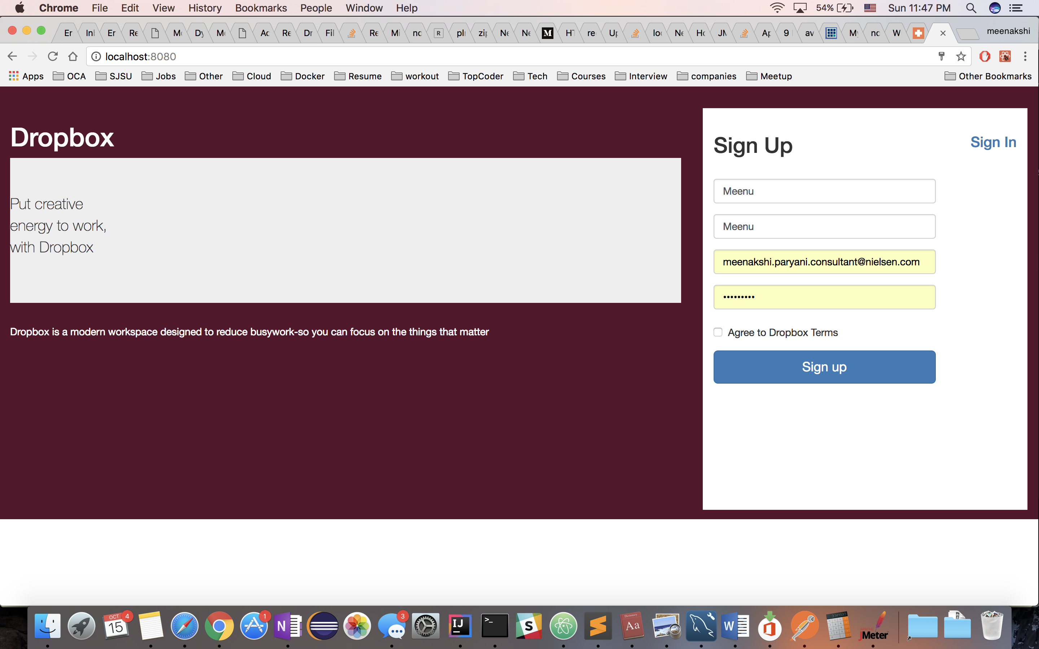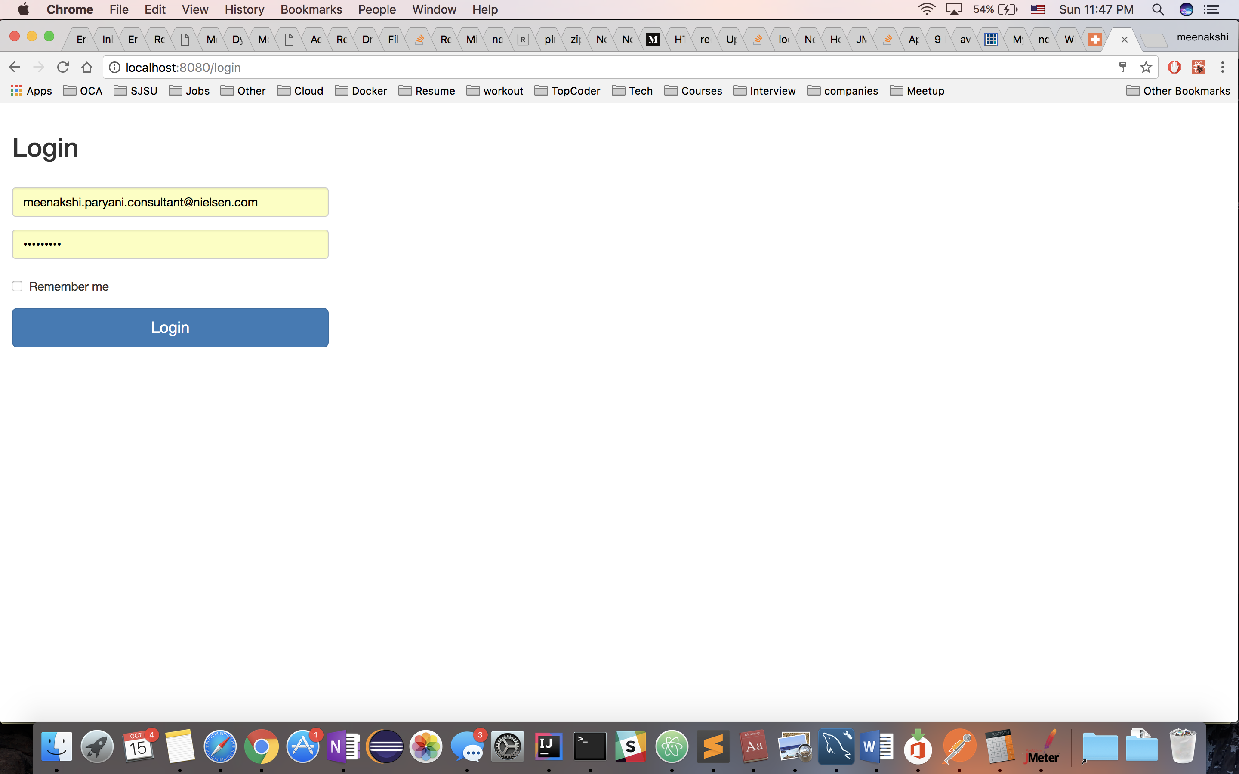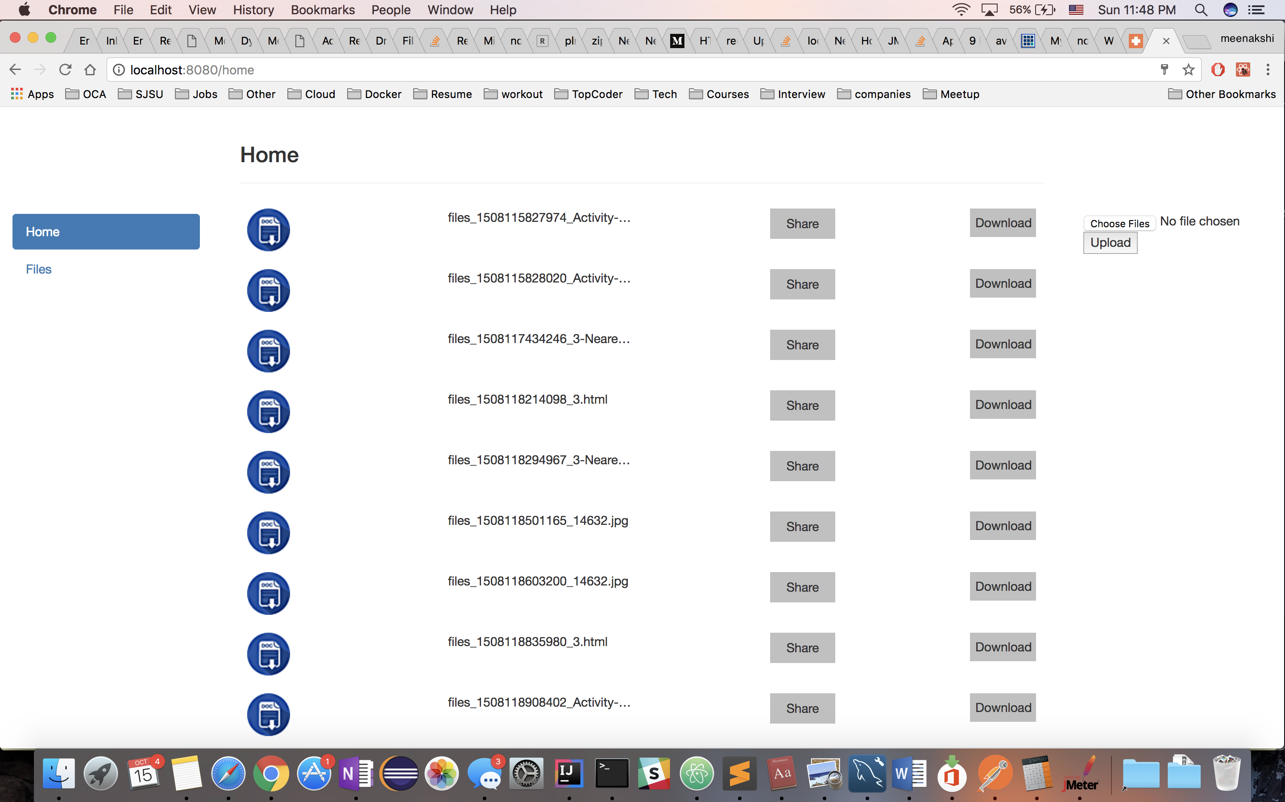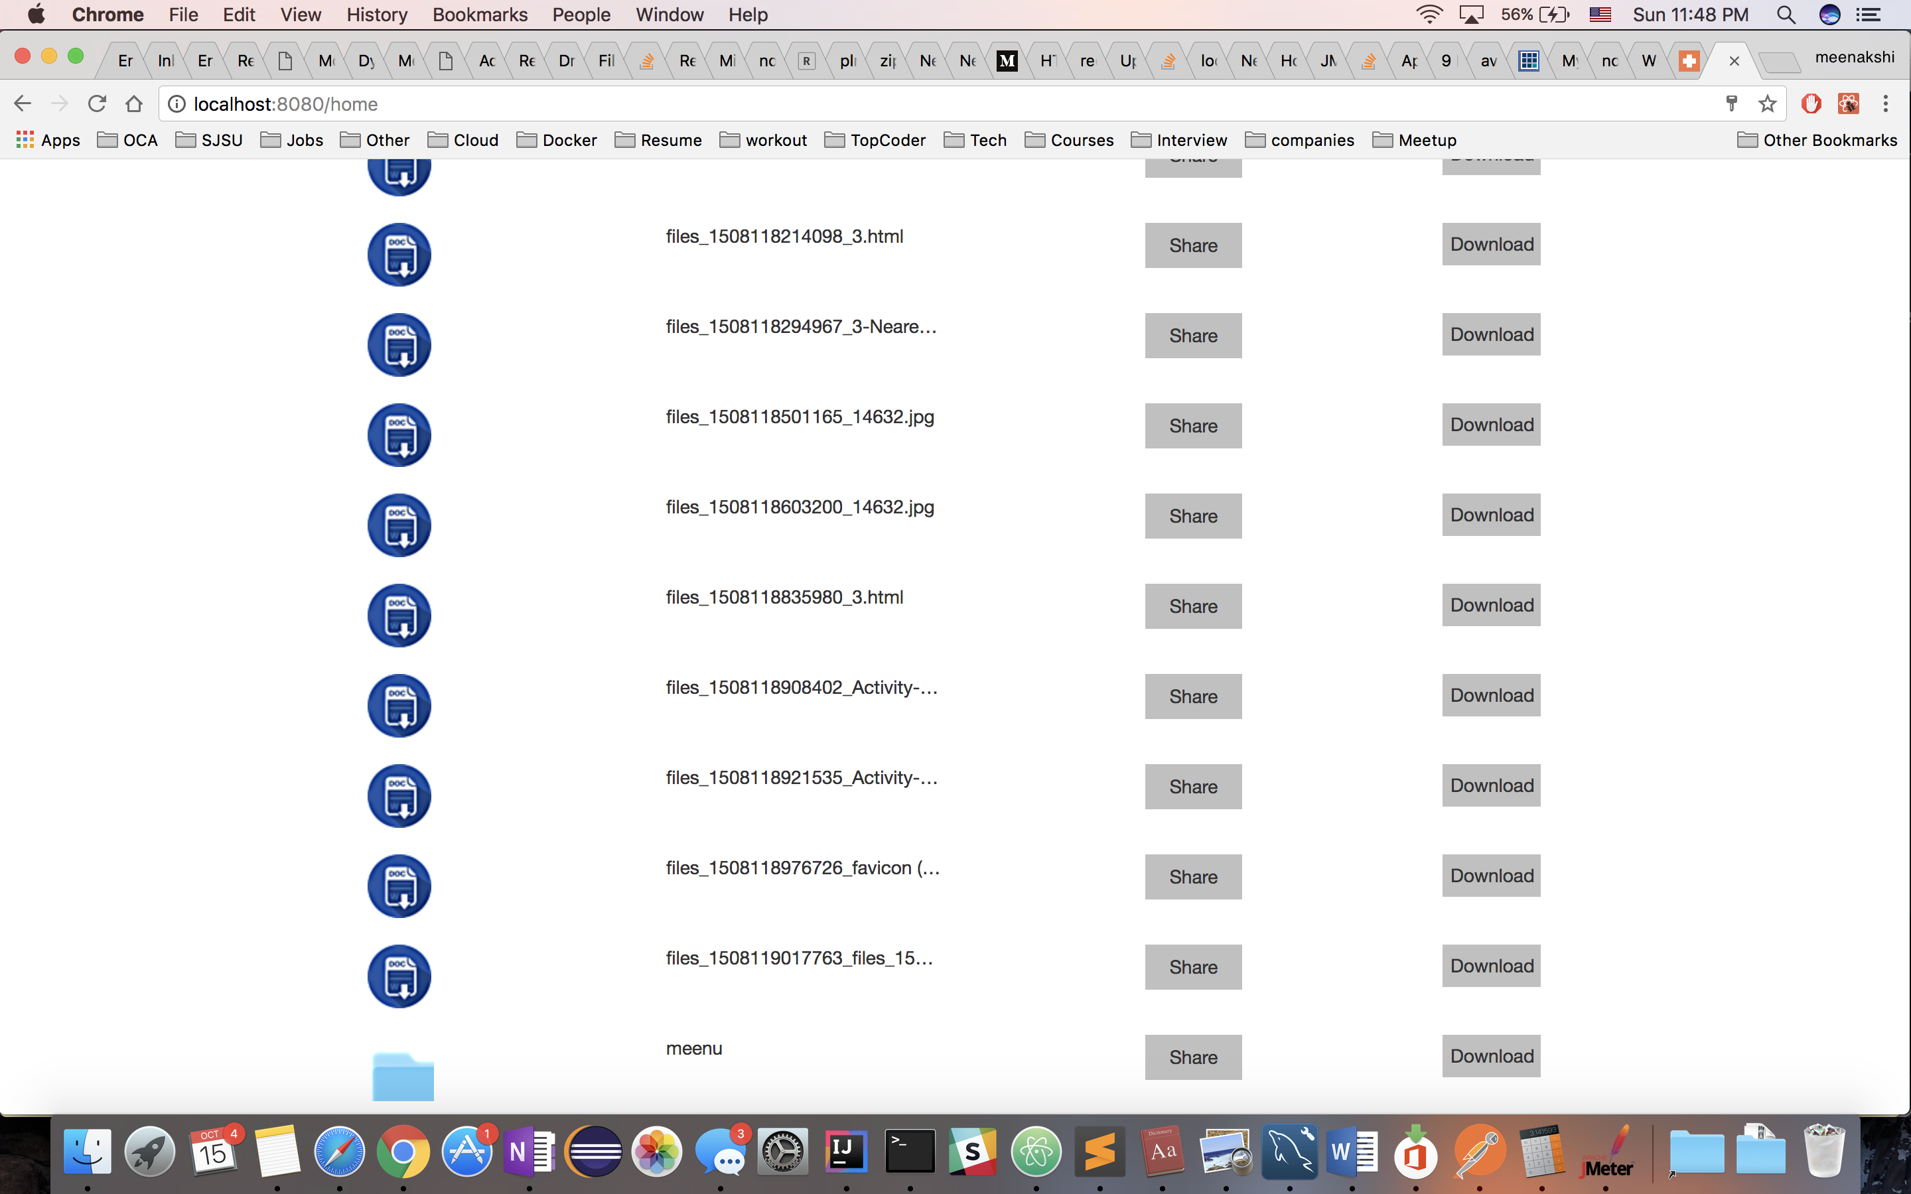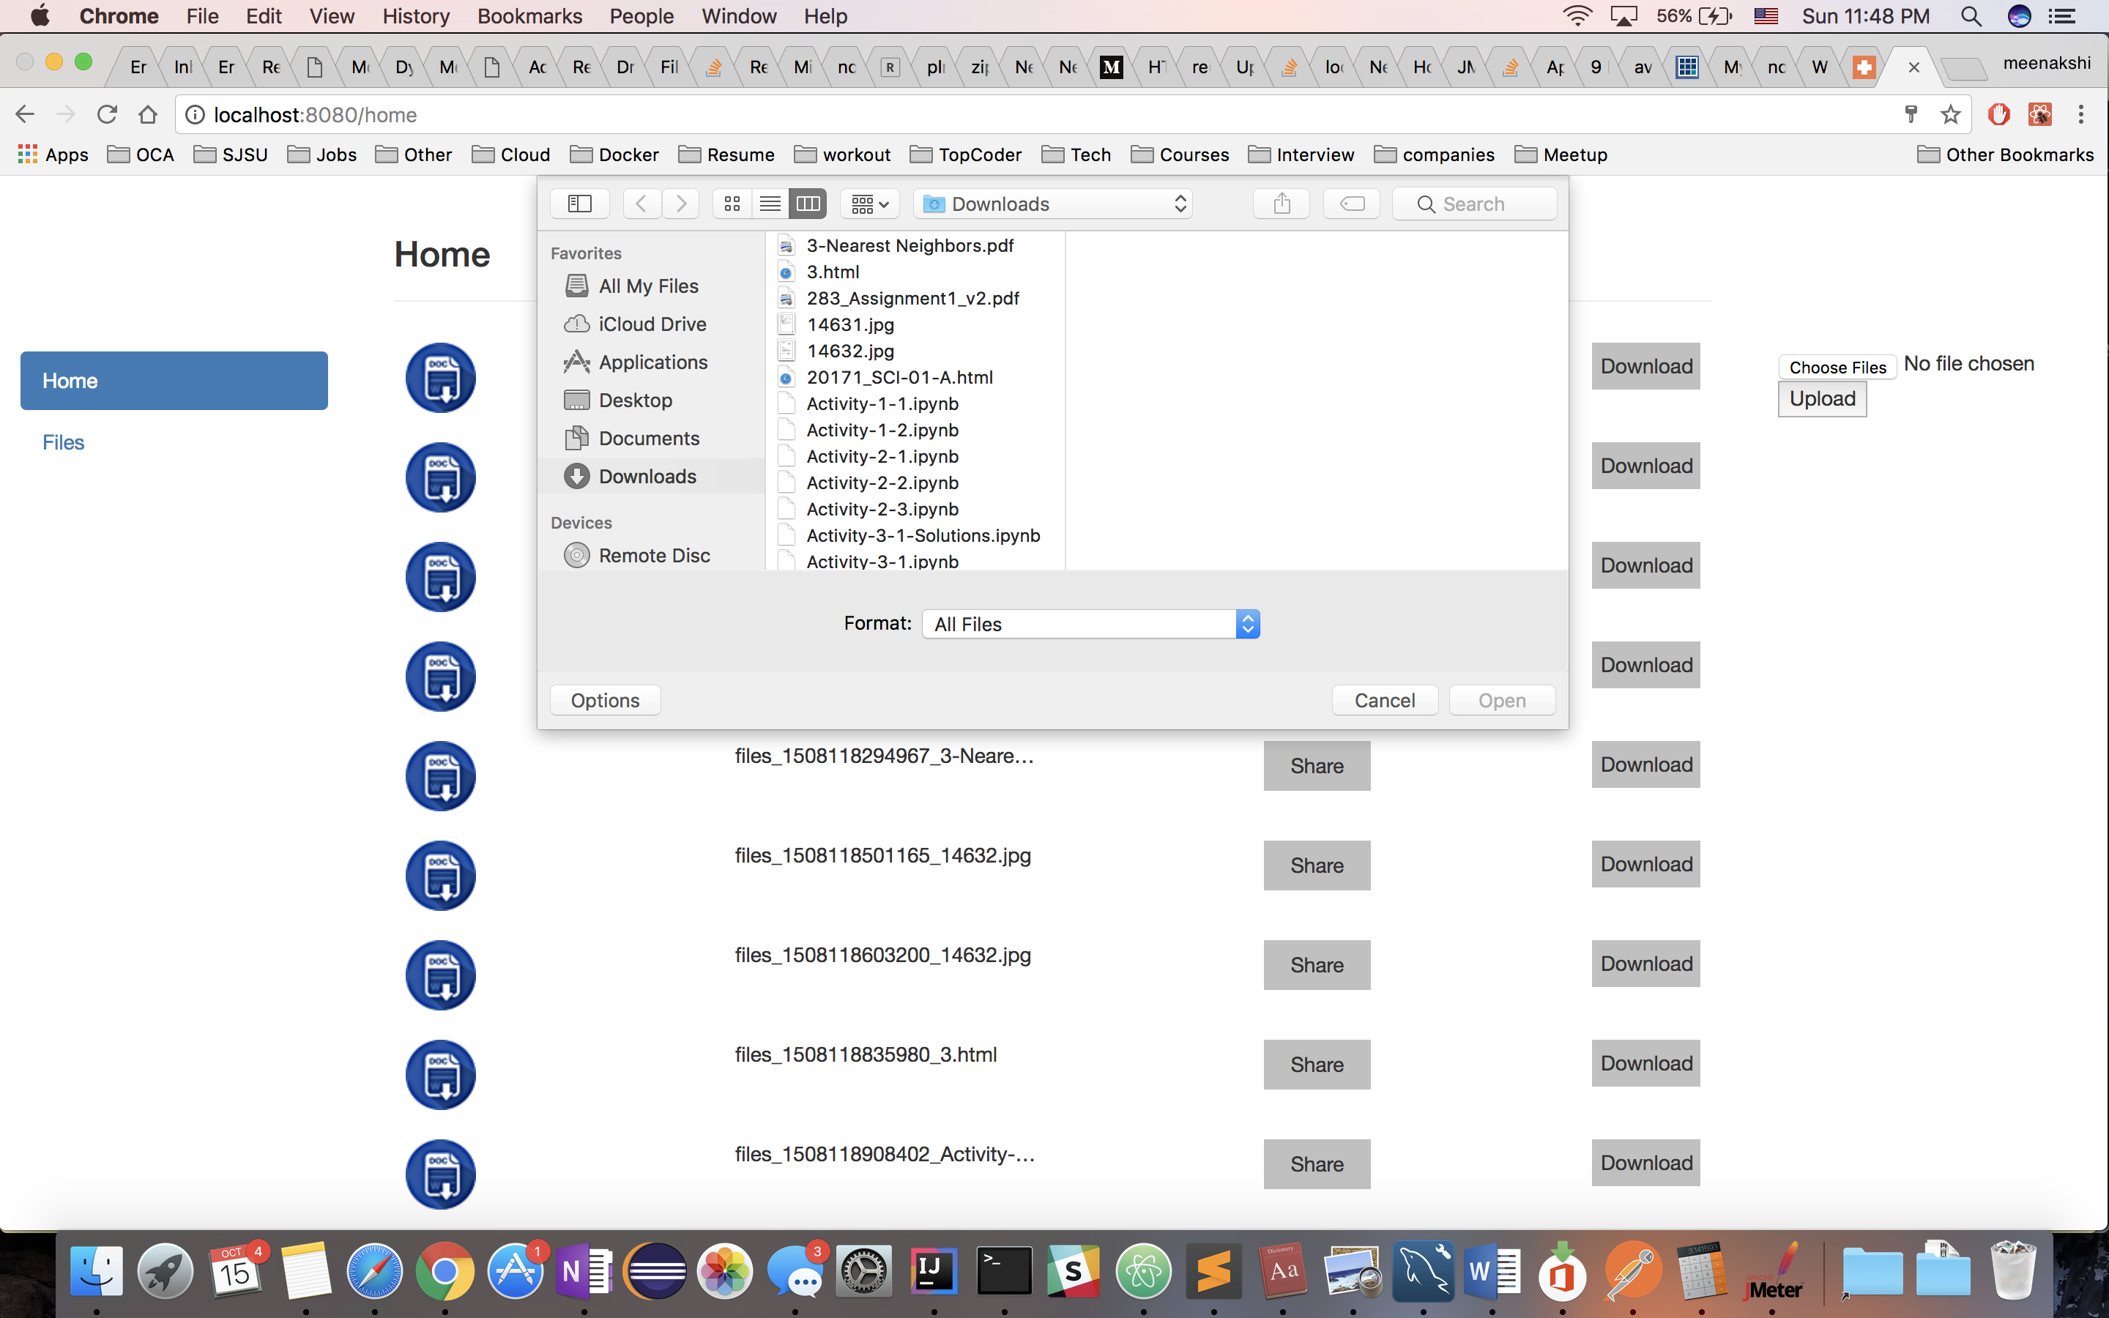

**Goals :**  For users to be able to upload files from anywhere and download anywhere with a good combination of session storage/ persistence, sql caching and connection pooling among other characteristics of the system.